Explanations

Data: Breakdown of COVID-19 positive hospital admissions
The data is obtained from: https://data.ontario.ca/dataset/breakdown-of-covid-19-positive-hospital-admissions/resource/d1199d1b-dc82-4e63-bb80-5c715e97a127
Data preprocessing:
- Load the raw csv into excel
- Get rid of the timestamps in the date by using “Text to Columns” using delimit by fixed width.

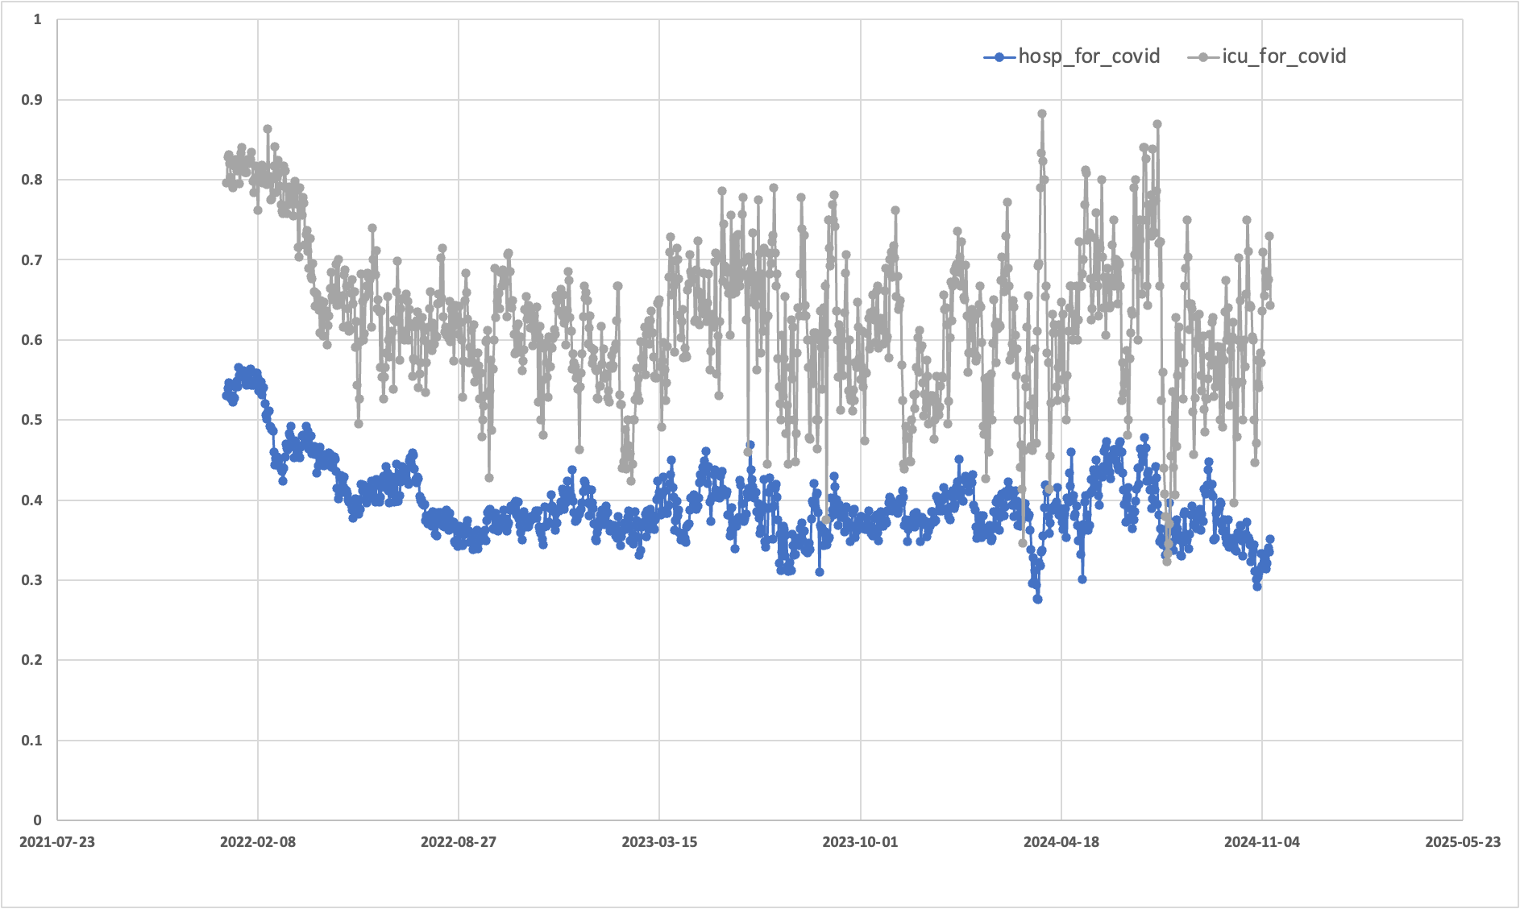
1. What software did you use to create your data visualization?
The data visualizations are creating using Excel.
2. Who is your intended audience?
The intended audience consists of clinical department heads, hospital resource planners, and public health analysts. The chart is designed for professionals who need to see the direct relationship between intensive care (ICU) and general ward COVID-19 burdens on a single, unified timeline.
3. What information or message are you trying to convey with your visualization?
The visualization conveys that COVID-19 consistently places a higher proportional strain on ICU resources than on general hospital beds. By plotting both metrics on the same axis, it highlights the "severity gap", showing that while general hospitalizations for COVID-19 may hover around 30-40%, the ICU occupancy for the same condition is significantly higher and more volatile, often staying above 50-60%.
4. What aspects of design did you consider when making your visualization?
I designed this plot to enable direct comparison by overlaying both series, emphasizing the gap between ICU and general ward burdens. Circular markers highlight daily volatility, while a contrasting blue and grey palette ensures clarity. By fixing the y-axis from 0 to 1, I maintained a consistent scale for interpreting these proportions relative to total capacity.
5. How did you ensure that your data visualizations are reproducible?
Reproducibility is maintained by keeping the source spreadsheet linked to the Excel workbook. However, because Excel is a GUI-based tool rather than script-based, it is inherently less reproducible than code; if the specific workbook file or the "steps" taken to format the chart are lost, an observer cannot perfectly recreate the chart.
6. How did you ensure that your data visualization is accessible?
To ensure the visualization is accessible, I utilized distinct markers (circular points) on the lines so that the two data series could still be differentiated in high-contrast or grayscale modes where color might be lost. The legend is positioned clearly at the top right to provide an immediate key for the variables being measured.
7. Who are the individuals and communities who might be impacted by your visualization?
The primary communities impacted are healthcare workers and hospital staff, whose daily workloads are reflected in these occupancy trends. Patients with non-COVID-19 related conditions are also impacted, as this data illustrates how much of the "specialized" ICU capacity is being diverted away from general critical care.
8. How did you choose which features of your chosen dataset to include or exclude?
I specifically chose to include hosp_for_covid and icu_for_covid while excluding the "Other Conditions" features. This decision was made to narrow the viewer’s focus specifically to the burden of the virus itself across different intensities of care. By excluding the "Other Conditions" columns, I removed redundant information (since they are simply the inverse of the COVID-19 proportions), thereby reducing visual clutter and making the specific fluctuations in COVID-19 severity more apparent.
9. What ‘underwater labour’ contributed to your final data visualization product?
The "underwater labour" involved several manual data management tasks within the spreadsheet. This included formatting the raw date strings into a readable short-date format on the x-axis to prevent text overlapping and manually adjusting the bounds of the y-axis to ensure the data was not compressed. I also spent efforts to remove the time stamps.

